1. Inverse of the given string without using string function and another array.
2. Find out second largest number in an unsorted array.
3. Find number of bits set (i.e 1) in a given integer. e.g. (input: 7 output: 3).
4. Latin square matrix nxn

Input: 6

Output: 1 2 3 4 5 6

             2 3 4 5 6 1

             3 4 5 6 1 2

             4 5 6 1 2 3

             5 6 1 2 3 4

             6 1 2 3 4 5

1. Print word form to given  number

        E.g.: 1834

       As “one thousand eight hundred thirty four

1. Questions asked to me in interview were: Explain abstraction, inheritance, encapsulation, polymorphism with some examples.
2. Spiral matrix  
   Given a square matrix(n is odd) , print the elements in spiral order starting from the center till a[0][0]  
   A=  
   1 2 3  
   4 5 6  
   7 8 9  
   o/p 5 4 7 8 9 6 3 2 1
3. Lower triangle matrix

Given “n” print the following  
N=3  
1  
6 2  
5 4 3

1. Find all possible longest increasing subsequences from an given array

Array 0 2 6 4 8 7  
Ans :  
Maxium length 4  
0 2 6 8  
0 2 4 8  
0 2 4 7  
0 2 6 7

1. Write a C program to Remove even numbers and fill it with zeros.  
   Note: You can use only one loop for your logic.  
   Two variables apart from the array.  
   Input array 1,2,3,4,5,6  
   Output 1,3,5,0,0,0
2. Given a string , you have to predict whether it can be changed into a palindrome or not by changing the positions of the characters  
   Eg. Tests  
   Yes  
   Explanation:tests can be changed to tsest or stets
3. Given an array , find the nth largest and nth smallest number. Sorting should not be used
4. Print the pattern  
   N=4  
   4444444  
   4333334  
   4322234  
   4321234  
   4322234  
   4333334  
   4444444
5. (Partitioning and merging)  
   Given an array and a partition size, you have to partition the array with that value , then we will specify the partition order , you have to merge based on that order  
   Array : 1 2 3 4 5  
   Partition size 2  
   (so the array will be partitioned as 1 2, 3 4, 5)  
   Partition order 3 2 1  
   o/p: 5 3 4 1 2
6. Implement a sql multiple join query using C program.
7. to find the permutation of any word eg:"abc" had to be coded

Below are the permutations of string ABC.  
ABC, ACB, BAC, BCA, CAB, CBA

Here is a solution using backtracking.

[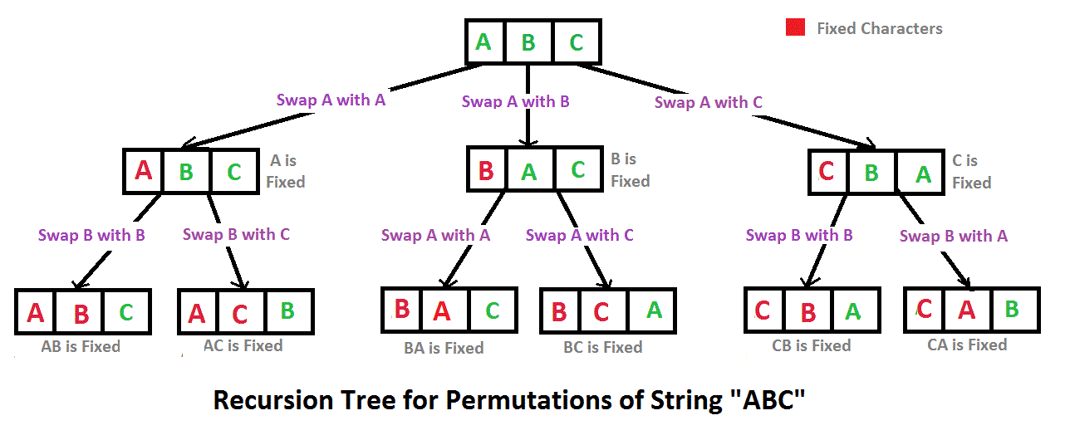](http://d2o58evtke57tz.cloudfront.net/wp-content/uploads/NewPermutation.gif)

1. Given a n (large number) lists of customers who visited n webpages on n (large number) days, design a data structure to get customers who have visited the website on exactly "k" days and should have visited at least "m" distinct pages altogether.
2. Create an algo for horse movement in chess board
3. How many buckets of water would be needed to fill this room?
4. How much litres of milk would chennai city consume in a month in average?
5. Reverse Each word in a String
6. Given a sentence and a pattern, find the number of occurences of the pattern in the sentence
7. Write a Java program to count the number of occurances of each number in a series of numbers.
8. Why the man hole are in circle.
9. What is active directory
10. find the number of times a given pattern of string appears in a given string
11. display the elements from two arrays which do not belong to both the arrays
12. to display a pascal triangle pattern
13. sql query to do some basic operations on database
14. to transfer contents of a file to another file
15. juice filled in a 24 litre bottle to be split equally into three parts using an 8 litre, 5 litre, 11 litre bottles.

Ans 1: split into 8L

fill 8L bottle from 24L bottle

pour contents on 8L bottle into 11L bottle

fill 8L bottle

now we have 8L in 24L,8L and 11L bottles

1. profit or loss if a horse is bought for 60 rs, sold for 70, again bought for 80, then sold for 90.
2. from c:-----

1.some basic programs from <http://cquestionbank.blogspot.com/>

2.basic question like difference between structure and union.

3.different types of pointer.

4.functions

5.call by value and call by reference.

6.recursion.

1. from c++  :----------

1.virtual function and pure virtual function

2.static variable and static methods.

3.inheritance.

4.overloading programs

5.types of constructors.

6.difference between c,c++ and java.

some programs

1. from java :--------------------------

note:-this is the java development based company.so they will ask alot of questions from

java.

you should be must well in java.

all basic questions from:

1.exception handling

2.string

3.collections

4.serialization

5.interface.

1. we have given two hour glass one of 11 minute and one of 7 minute. Then how  
   will we calculate the15 minute time.
2. How to find the second largest number in an array???(using single for loop or through single traversal)
3. In a given string you should have the count of no of a,e,i,o,u and others(For eg: I AM SAM

A:2,E:0,I:1,O:0,U:0,others:5(including spaces)).And print them as follows

A:2,E:0,I:1,O:0,U:0,others:5

1. In the above program print only the top 3 counts.

i.e Others:5,A:2,I:1

1. Prove Zeckendorf theory.
2. Input={[surya,diya],[karthi,umayal],[sivakumar,karthi],[sivakumar,surya],[prabhu,vikram],[sivaji,prabhu]}

In this ,you should get a name as an input and the result should be nothing but printing their grandchild’s name.For eg: if input is sivakumar the output should be diya and umayal.

1. Consider an array of length n and the no’s are less than (n-1) and so one no would be repeating.For eg: length=5 .The array is {1,2,3,2,4}.here you have to find the repating no in an array using single for loop.
2. Find a no within a given range such that the number is equal to the sum of factorial of the digits.For eg: 145=1!+4!+5!.